**Remining and restoration of abandoned mining sites in the US: the case for materials needed for zero-carbon transition**

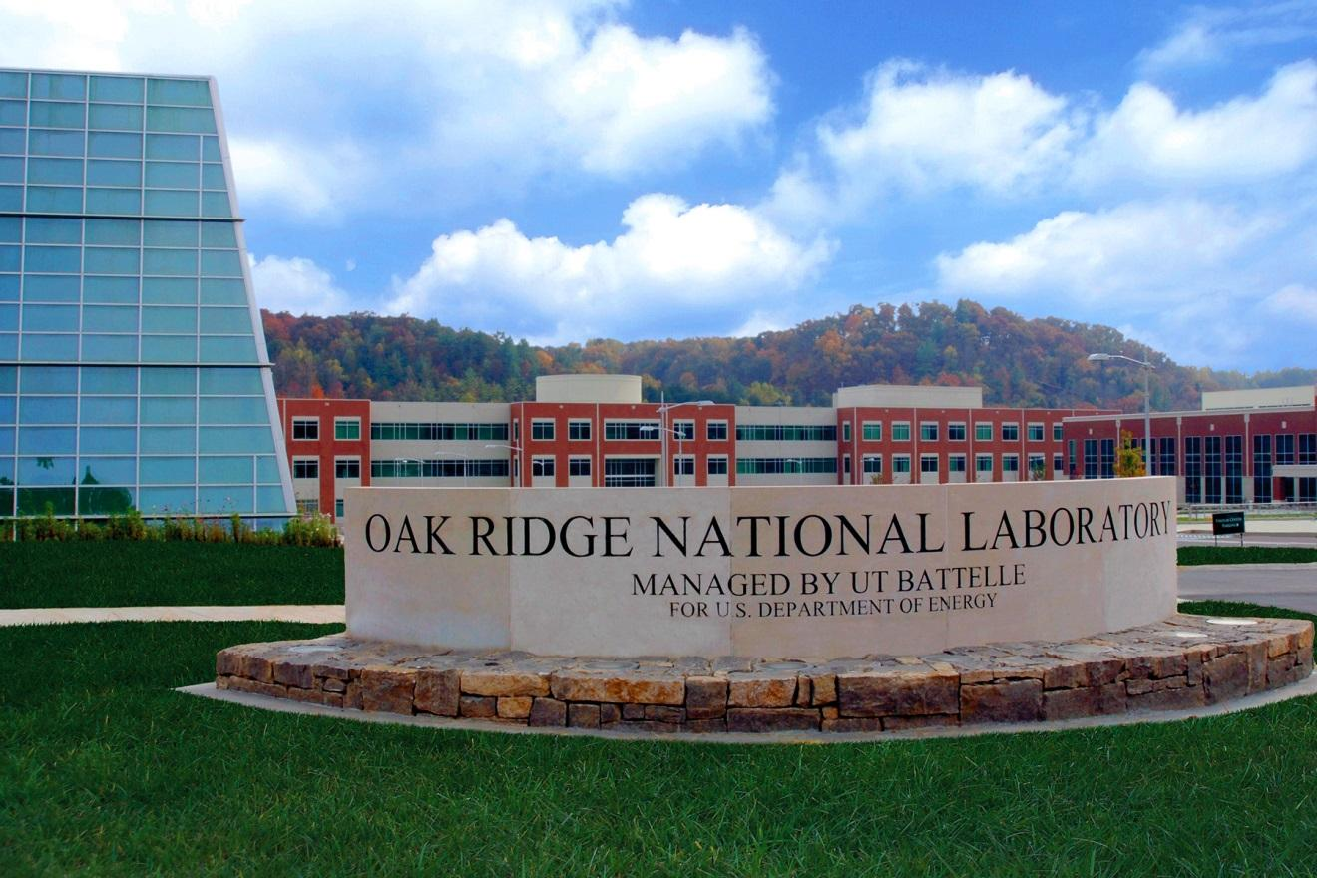

Dinara Ermakova

Jin Whan Bae

**August 2022**

| **DOCUMENT AVAILABILITY** |
| --- |
| Reports produced after January 1, 1996, are generally available free via OSTI.GOV.  ***Website*** [www.osti.gov](http://www.osti.gov/)  Reports produced before January 1, 1996, may be purchased by members of the public from the following source:  National Technical Information Service  5285 Port Royal Road  Springfield, VA 22161  ***Telephone*** 703-605-6000 (1-800-553-6847)  ***TDD*** 703-487-4639  ***Fax*** 703-605-6900  ***E-mail*** info@ntis.gov  ***Website*** <http://classic.ntis.gov/>  Reports are available to US Department of Energy (DOE) employees, DOE contractors, Energy Technology Data Exchange representatives, and International Nuclear Information System representatives from the following source:  Office of Scientific and Technical Information  PO Box 62  Oak Ridge, TN 37831  ***Telephone*** 865-576-8401  ***Fax*** 865-576-5728  ***E-mail*** reports@osti.gov  ***Website*** <https://www.osti.gov/> |
| This report was prepared as an account of work sponsored by an agency of the United States Government. Neither the United States Government nor any agency thereof, nor any of their employees, makes any warranty, express or implied, or assumes any legal liability or responsibility for the accuracy, completeness, or usefulness of any information, apparatus, product, or process disclosed, or represents that its use would not infringe privately owned rights. Reference herein to any specific commercial product, process, or service by trade name, trademark, manufacturer, or otherwise, does not necessarily constitute or imply its endorsement, recommendation, or favoring by the United States Government or any agency thereof. The views and opinions of authors expressed herein do not necessarily state or reflect those of the United States Government or any agency thereof. |
|  |

**ORNL/TM-2022/2591**

[Nuclear Energy and Fuel Cycle Division](https://www.ornl.gov/division/nefc)

**Remining and restoration of abandoned mining sites in the US: the case for materials needed for zero-carbon transition**

Dinara Ermakova, Jin Whan Bae

August 2022

Prepared by

OAK RIDGE NATIONAL LABORATORY

Oak Ridge, TN 37831

managed by

UT-BATTELLE LLC

for the

US DEPARTMENT OF ENERGY

under contract DE-AC05-00OR22725

**CONTENTS**

**ABSTRACT** **4**

**INTRODUCTION** **5**

**CRITICAL AND IN-DEMAND MATERIALS FOR LOCAL RENEWABLE ENERGY PRODUCTION** **6**

**SOLUTION FOR THE SUPPLY CHAIN AND ABANDONED MINES** **13**

3.1. ECONOMIC MOTIVATION 13

3.2. FEASIBILITY STUDY 15

3.3. AN ENVIRONMENTAL JUSTICE (EJ) ASPECT 18

**CONCLUSION** **18**

**ACKNOWLEDGEMENT** **19**

**REFERENCES** **20**

# ABSTRACT

Since it is responsible for 25% of the world's greenhouse gas (GHG) emissions, the electricity generation sector has been the focus of efforts to transition to clean energy and sustainable development in many nations. In the last 20 years, renewable energy sources have been the fastest-growing energy source in the world, making up almost 29% of the world's electricity in 2020. They are expected to make up nearly 95% of the world's power capacity growth through 2026, with a share in the same year up to 46%.

On the other hand, the rapid development of renewable sources of energy and the technologies needed will require an enormous amount of raw material to build capacity in order to replace coal and gas plants due to the low power-density of such sources (1.2W/m2 for wind and 6.7W/m2 for solar, compared to 28W/m2 for natural gas and 57W/m2 for nuclear power) and their intermittent behavior, as well as to increase the capacity to follow the growing electricity demand. Taking into account the expected scale of rapid deployment of renewable energy sources that require rare earth elements, cement, and steel, the mining industry may face a supply problem for the critical materials for clean energy and hence may be provided with economic stimuli to grow the supply.

At the same time, the mining sector is another GHG contributor, responsible for 8% of total GHG. The increasing demand for a growing capacity of renewable energy resources will keep mining a threat to biodiversity without proper regulations and calls for remining, cleanup, and circular economic development. The effects are worst in developing countries, such as Chile, China, and Peru, which are leading producers of metals and minerals, provide cheap labor and have less stringent environmental and public health protection regulations. These factors will greatly exacerbate the problem of environmental injustice in those countries and locally.

In this study, we have explored the opportunity of remining abandoned mining waste to extract metals and minerals essential for the production of renewable energy systems. These abandoned mining sites can have a second life with newer technologies to extract valuable materials from mining waste rock, tailings, and landfills, especially with the economic stimulus provided by growing material demand. We have analyzed what materials are used in the production of these technologies; what materials are only available for import; and which materials can be extracted locally in the U.S.

The lack of alternative supply mechanisms will influence the geopolitical situation, leading to unpredictable price changes controlled by the countries that own more critical resources, such as rare earth elements and the way to process them from ore. The dependence on the centralized export of materials needed for renewable sources of energy poses a threat to energy security and diversity in countries that do not possess technology-specific materials. Remining activities may provide the first stage of cleanup of abandoned mines, offsetting some of the costs required for the cleanup, providing jobs and infrastructure to a local population, and providing control over remining and cleanup activities to a local community, who will be affected by either a lack of cleanup or benefit from the access to new resources on the first hand. Providing these choices to local communities will provide just distribution of resources, restore the sites and provide control over the sites.

# INTRODUCTION

Since over 60% of electricity is produced using fossil fuels today, rapid decarbonization is difficult to achieve without a significant change in the way electricity is generated and distributed. This leads to constant greenhouse gas (GHG) emission growth as the energy demand will continue to grow in order to provide electricity and economic growth, better healthcare, and access to education to a wider range of populations and geographies [[1]](https://paperpile.com/c/7t4MlO/ltxE). In the last 20 years, renewable energy sources have been the fastest-growing energy source in the world [[2]](https://paperpile.com/c/7t4MlO/3MUiv). Renewables made up almost 29% of the world's electricity in 2020 [[3]](https://paperpile.com/c/7t4MlO/47hcW), and they are expected to make up nearly 95% of the world's power capacity growth through 2026, with a projected share of the electricity generation portfolio of 46%, with solar PV making up more than half of that. Between 2021 and 2026, the amount of renewable capacity added is expected to be 50% higher than between 2015 and 2020 [[4]](https://paperpile.com/c/7t4MlO/gzztf). The recent Bipartisan Infrastructure Law [[5]](https://paperpile.com/c/7t4MlO/XucX) has shown the efforts the US is willing to make to cut the environmental impact and slow global climate change.

On the other hand, the rapid development of renewable sources of energy and the technologies needed to build these systems will require an enormous amount of raw material to be extracted. The power density of renewable sources is relatively lower compared to coal or gas, and thus, to replace any of these systems, it may be required to use more raw materials to build renewable energy systems [[6](https://paperpile.com/c/7t4MlO/RUomg+o4QIr)-[9]](https://paperpile.com/c/7t4MlO/NujaX+7UQMm). Taking into account the expected scale of rapid deployment of renewable energy sources that require rare earth elements (REE), cement, copper, chromium, zinc, and steel, the mining sector will have to keep up with the supply of these materials. At the same time, the mining sector is another GHG contributor, responsible for 8% of total GHG. The increasing demand for a growing capacity of renewable energy resources will keep mining a threat to biodiversity without proper regulations and calls for remining, cleanup, and circular economic development [[10-12]](https://paperpile.com/c/7t4MlO/qobBO+AFgDY). The effects are worst in developing countries, which own some of the of raw materials reserves, provide cheap labor, and have less stringent environmental and public health protection regulations. These factors will greatly exacerbate the problem of environmental injustice in those countries and, locally, in the US as well.

These types of impacts at mine sites and along the supply chain also influence the geopolitical situation, leading to unpredictable price changes controlled by the countries that own more critical resources, such as rare earth elements and the way to process them from ore. The dependence on the centralized export of materials needed for renewable sources of energy poses a threat to energy security and diversity in countries that do not possess technology-specific materials. Despite the massive outsourcing of mining of critical materials to other countries, countries like the USA have thousands of abandoned mining sites with mining waste that still contain valuable minerals and metals whose extraction was not economical previously [[13–15]](https://paperpile.com/c/7t4MlO/6cij+dXKG+90D4). These mines could have a second life with newer technologies to extract valuable materials from mining waste rock, tailings, and landfills.

In this study, we have explored the opportunity of remining abandoned mining waste to extract metals and minerals essential for the production of renewable energy sources. To do this, we have analyzed what materials are used in the production of these technologies; what materials are readily available in the US; and which materials can be extracted locally in the U.S. from abandoned mine waste. We have also explored the issue of environmental injustice that populations residing in areas near mining sites experience and the way to mitigate it by providing more control over the extraction and cleanup activities and by providing more job opportunities in those areas while offsetting some of the costs associated with cleanup and land restoration projects.

# CRITICAL AND IN-DEMAND MATERIALS FOR LOCAL RENEWABLE ENERGY PRODUCTION

According to the International Energy Agency, in the next decades, the USA will expect to increase its electricity generation and grow its capacity. With that, the share of coal in the portfolio will be significantly reduced to cut emissions (Fig 1). Solar and wind will see significant growth in their share of the electricity generation portfolio. Renewable energy technologies will require infrastructure upgrades and are already changing material demand patterns [[16]](https://paperpile.com/c/7t4MlO/VbBR). Since the majority of greenhouse gas emissions from renewable technologies are embodied in infrastructure (up to 99% for photovoltaics), there may be wide variations in lifecycle impacts depending on the source of the raw materials, their origins (mining sites), the mix of energy used in production, the mode of transportation used at different stages of manufacturing and installation, etc. (Fig 2). These variations refer to the embodied impact, or the energy and emissions (such as CO2) released to create, manufacture, transport, use, and dispose of each technology. The final life-cycle assessment score, which may be significantly lowered if the infrastructure is more durable than anticipated, depends heavily on the load factor and expected equipment lifetime since impacts are embodied in the capital [[17]](https://paperpile.com/c/7t4MlO/rwCq). It is important to lessen their embedded impact through recycling, local mining, and reviving abandoned mines to extract necessary materials, as embedded carbon emissions are locked in place as soon as a project is built, unlike operational carbon emissions, which can be reduced over time with technological advancements. To reduce the embedded carbon we need to:

* **Reuse**, including the materials that can be reused (concrete foundations, frames, steel elements, etc.); use recycled materials, and design modular components for future recycling; recycling mining waste instead of spending resources on a cleanup effort first
* **Reduce**, including material optimization and the specification of low to zero carbon materials.
* **Repurpose**, including the sites that are no longer suitable for resident use. Recycled mining sites can be suitable for this purpose.
* **Produce locally**, avoiding the outsourcing of the carbon emissions for mining activities to other countries, as well as being accountable for the waste generated in the process and clean-up activities.

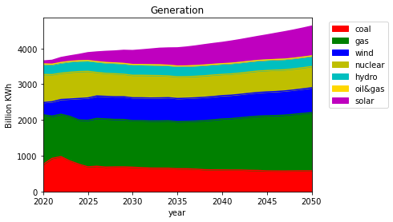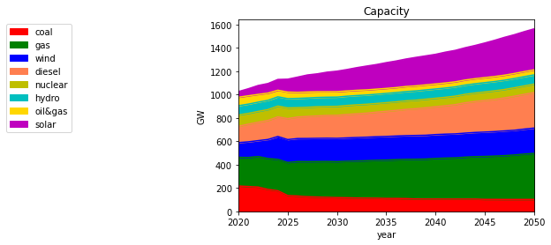

*Figure 1: Electricity generation and capacity changes in the U.S. from 2021 to 2050 (EIA).*

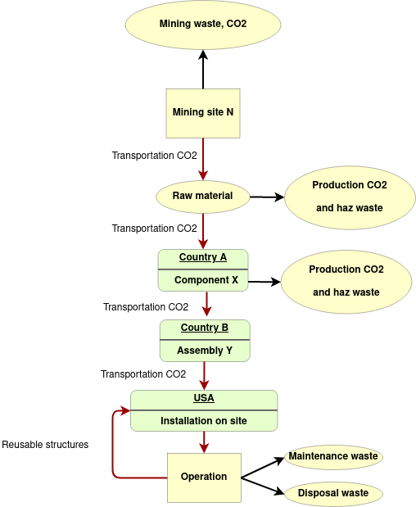

*Figure 2. The renewable energy life cycle example*

In a low-carbon future, it is anticipated that less coal and gas will be extracted, but that the demand for more than 20 energy transition metals, including iron, copper, aluminum, nickel, lithium, cobalt, platinum, silver, and rare earth metals, will rise [[18,19]](https://paperpile.com/c/7t4MlO/dTNE+NHi5). Here we are focusing more on the materials needed and the potential to extract these materials in the US by recycling the abandoned mining waste. Tables 1-3 show the material demand, what is currently recycled, what structures can sustain multiple life cycles, and the mining waste generated from renewable energy sources such as wind, crystalline silicon (c-Si) solar, and hydroelectric in the case of the raw material extracted from a pristine mining ore. According to the IEA, hydroelectric power will not see a huge expansion in capacity. As it can be seen, the amount of mining waste can reach several million tons per MW of added capacity and pounds per MWh generated (Fig 3) if pristine mining ore is used, especially if the mining occurs at a different location without using different processing streams to extract byproducts as well.

*Table 1. Raw material demand and mining waste generation to build a solar farm.*

| **Material** | **Amount**  **in kg/MW** | **Ore fraction %** | **Mining waste**  **kg/MW** | **Recycling and reusing factors** | **source** |
| --- | --- | --- | --- | --- | --- |
| Silica | 7000 | ore grade about 35% and 50% of Si goes into waste during manufacturing. | 33000 | 0 | [[20]](https://paperpile.com/c/7t4MlO/tvzei) |
| Aluminum | 19000 | 30% | 44333.3 | 0.76 | [[21–23]](https://paperpile.com/c/7t4MlO/DQwVv+vxVFG+X9nMk) |
| Concrete | 47000 | 67% for cement, and concrete contains 21% of cement, sand, gravel, and water. | 6612.9 | 1 | [[22,24]](https://paperpile.com/c/7t4MlO/OAhEF+vxVFG) |
| Glass | 70000 | 35% | 130000 | 0 | [[20]](https://paperpile.com/c/7t4MlO/tvzei) |
| Copper | 7000 | 2% | 343000 | 0.6 | [[20,25]](https://paperpile.com/c/7t4MlO/tvzei+MHJcC) |
| Steel | 56000 | 65% | 30153.85 | 0 | [[20,26]](https://paperpile.com/c/7t4MlO/tvzei+epWdK) |
| Germanium | 440 | 0.015% | 1099560 | 0 | [[20,27]](https://paperpile.com/c/7t4MlO/tvzei+xqM7J) |
| Indium | 380 | 0.01% | 3799620 | 0 | [[20,28]](https://paperpile.com/c/7t4MlO/tvzei+y7NYz) |
| Plastic | 6000 | - | - | 0 | [[20]](https://paperpile.com/c/7t4MlO/tvzei) |
| Lead | 2.4 | 1.732 | 136.17 | 0 | [[29–31]](https://paperpile.com/c/7t4MlO/Z3Ehv+3XudE+dneOc) |
| Polyamide Injection Molded | 485 | - | - | 0 | [[32,33]](https://paperpile.com/c/7t4MlO/hQCmV+rskIW) |
| Polyester | 300 | - | - | 0 | [[32,33]](https://paperpile.com/c/7t4MlO/hQCmV+rskIW) |
| Polyethylene, Hd | 150 | - | - | 0 | [[32,33]](https://paperpile.com/c/7t4MlO/hQCmV+rskIW) |
| Vegetable Oil | 6001 | - | - | 0 | [[32,33]](https://paperpile.com/c/7t4MlO/hQCmV+rskIW) |
| Tin | 463.1 | 50% | 463.1 | 0 | [[34,35]](https://paperpile.com/c/7t4MlO/N7SUt+0qnC0) |
|  |  | **Total mining waste** | 5486879.32 |  |  |

*Table 2. Raw material demand and mining waste generation to build wind turbines.*

| **Material** | **Amount**  **in kg/MW** | **Ore fraction %** | **Mining waste**  **kg/MW** | **Recycling and reusing factors** | **source** |
| --- | --- | --- | --- | --- | --- |
| Aluminum | 8026.8 | 30% | 18729.2 | 0.76 | [[36]](https://paperpile.com/c/7t4MlO/Rc6LK) |
| Brass Cu | 52.3776 | 2% | 2566.5 | 0 | [[36]](https://paperpile.com/c/7t4MlO/Rc6LK) |
| Brass Zn | 26.2 | 3% | 847.13 | 0 | [[37]](https://paperpile.com/c/7t4MlO/Kt7W8) |
| Cast iron | 47350.4 | 65% | 25496.37 | 1 | [[36]](https://paperpile.com/c/7t4MlO/Rc6LK) |
| Concrete | 2246400 | 67% for cement, and concrete contains 21% of cement, sand, gravel, and water. | 316068.48 | 1 | [[36]](https://paperpile.com/c/7t4MlO/Rc6LK) |
| Copper | 5568 | 2% | 272832 | 0.6 | [[36]](https://paperpile.com/c/7t4MlO/Rc6LK) |
| Fiberglass | 3490.8 | - | - | 0 | [[36]](https://paperpile.com/c/7t4MlO/Rc6LK) |
| Steel | 540710 | 65% | 291151.54 | 1 | [[36]](https://paperpile.com/c/7t4MlO/Rc6LK) |
| Lubricant | 3304 | - | - | 0 | [[36]](https://paperpile.com/c/7t4MlO/Rc6LK) |
| Paint | 1311.12 | - | - | 0 | [[36]](https://paperpile.com/c/7t4MlO/Rc6LK) |
| Polyethylene | 329.4 | - | - | 0 | [[36]](https://paperpile.com/c/7t4MlO/Rc6LK) |
| Polymer | 5888 | - | - | 0 | [[36]](https://paperpile.com/c/7t4MlO/Rc6LK) |
| Porcelain | 104.98 | - | - | 0 | [[36]](https://paperpile.com/c/7t4MlO/Rc6LK) |
| Neodymium | 216 | 5% | 4104 | 0 | [[38–40]](https://paperpile.com/c/7t4MlO/yQeDV+rzBD9+mMi8n) |
| Praseodymium | 40 | 5% | 760 | 0 | [[39,41]](https://paperpile.com/c/7t4MlO/rzBD9+HELO4) |
| Terbium | 5 | 5% | 95 | 0 | [[39,41]](https://paperpile.com/c/7t4MlO/rzBD9+HELO4) |
| Dysprosium | 17 | 5% | 323 | 0 | [[34,39]](https://paperpile.com/c/7t4MlO/rzBD9+N7SUt) |
| Cr | 902 | 31% | 2024.67 | 0 | [[42–44]](https://paperpile.com/c/7t4MlO/vbpJd+j2sk8+3QKBS) |
| Manganese | 80.5 | 35% | 149.5 | 0 | [[42,43,45]](https://paperpile.com/c/7t4MlO/vbpJd+j2sk8+FcAUC) |
| Molybdenum | 136.6 | 0.50% | 27183.4 | 0 | [[42,43,46]](https://paperpile.com/c/7t4MlO/vbpJd+j2sk8+pxZZ3) |
| Nickel | 663.4 | 9% | 6707.71 | 0 | [[42,43,47,48]](https://paperpile.com/c/7t4MlO/vbpJd+j2sk8+f68MB+qj9w0) |
|  |  | **Total mining waste** | 969038.5 |  |  |

*Table 3. Raw material demand and mining waste generation to build a hydroelectric plant.*

| **Material** | **Amount**  **in kg/MW** | **Ore fraction %** | **Mining waste**  **kg/MW** | **Recycling and reusing factors** | **source** |
| --- | --- | --- | --- | --- | --- |
| Aluminum | 1585.2096 | 0.3 | 3698.8224 | 0.76 | [[49]](https://paperpile.com/c/7t4MlO/as8OT) |
| Concrete | 7644000 | 67% for cement, and concrete contains 21% of cement, sand, gravel, and water. | 1075510.8 | - | [[50]](https://paperpile.com/c/7t4MlO/F1a44) |
| Copper | 874.5984 | 0.02 | 42855.3216 | 0.6 | [[49]](https://paperpile.com/c/7t4MlO/as8OT) |
| Iron | 60128.64 | 0.65 | 32376.96 | - | [[50]](https://paperpile.com/c/7t4MlO/F1a44) |
|  |  | **Total mining waste** | 1154441.904 |  |  |

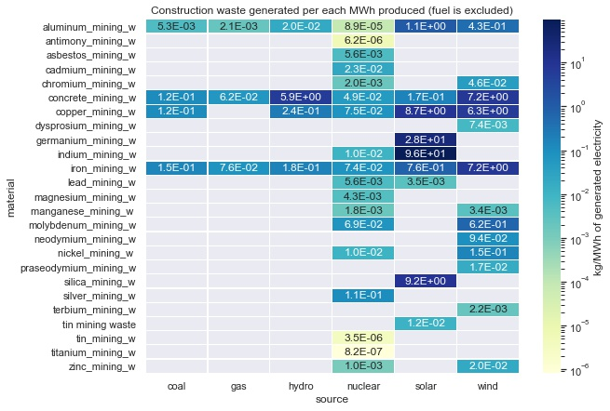

*Figure 3. Raw material supply change*

If iron, crushed rock, cement, and copper are abundant and their production is well established inside the country, there are materials that are mainly imported, and that pose a serious security threat to sustainable energy transition goals. The U.S. needs to have alternative supply solutions within the country, and abandoned mines can be a source of some critical materials that may bring economic value with today's prices and technologies. Fig 4 shows the critical materials that may require substitution because of their scarcity and accelerated demand [[51]](https://paperpile.com/c/7t4MlO/3lIa).

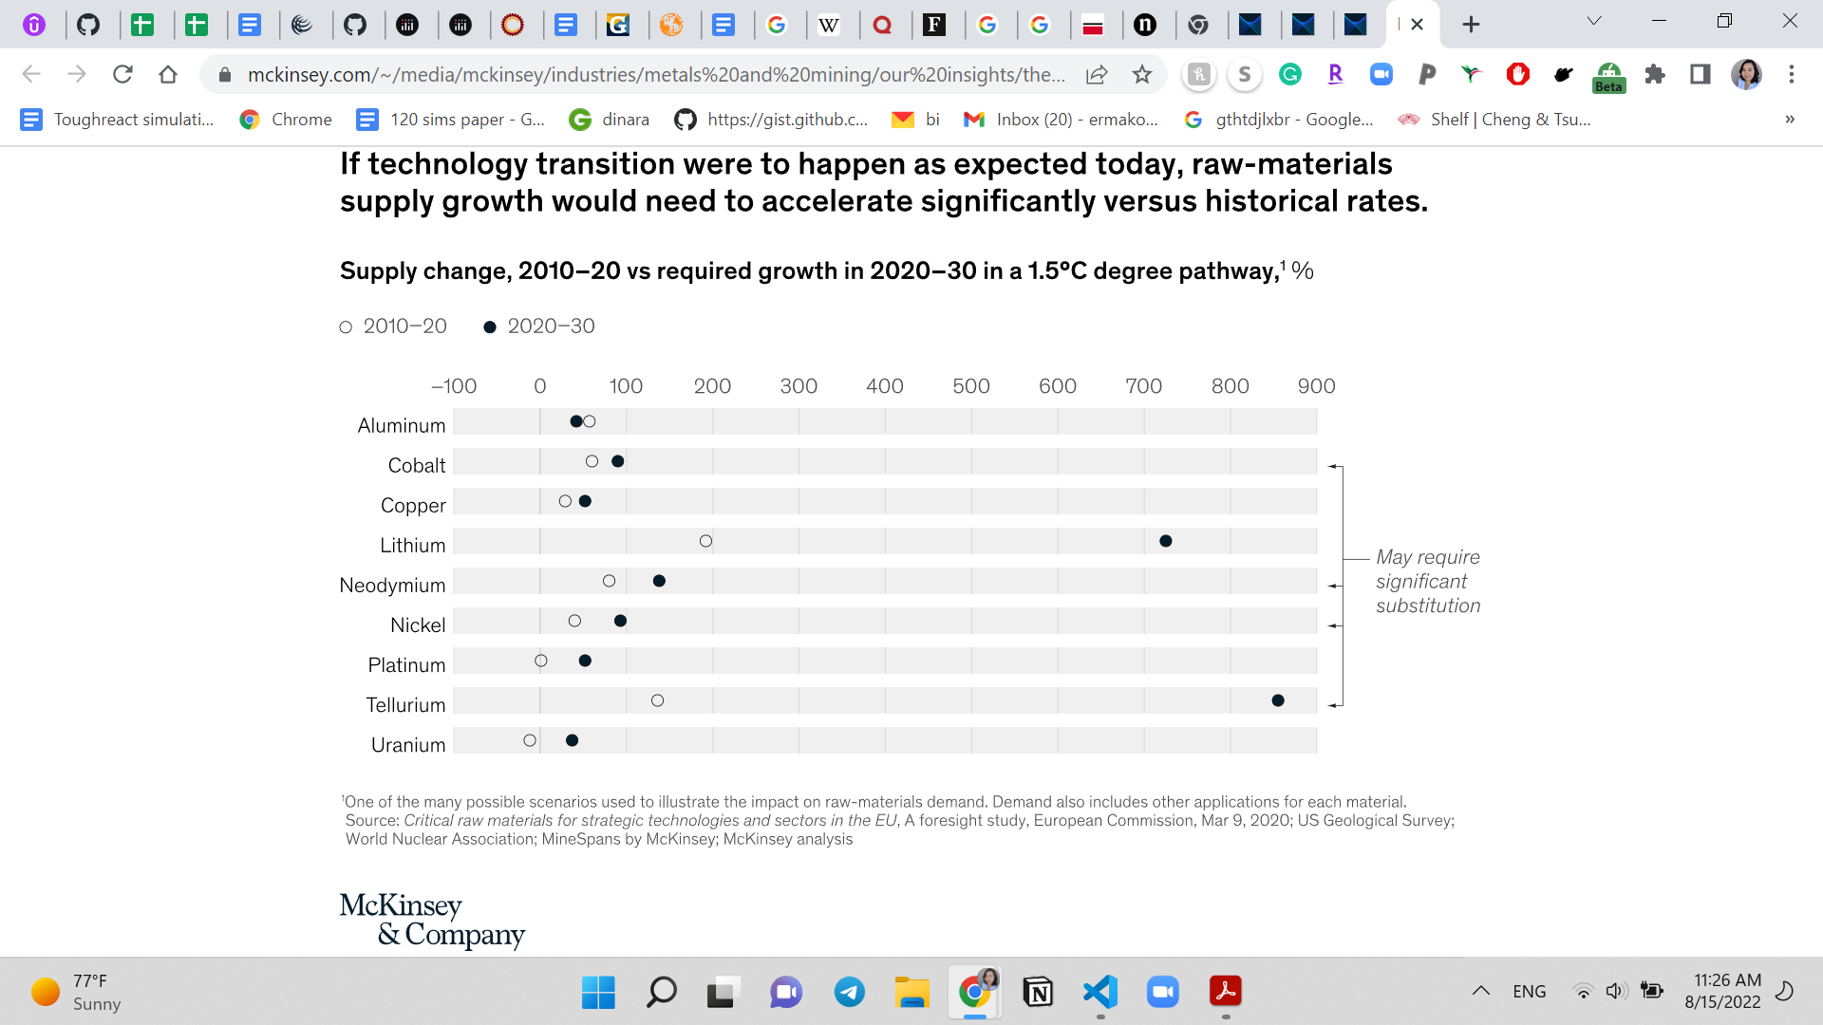

*Figure 4. Raw material supply change*

# 

# SOLUTION FOR THE SUPPLY CHAIN AND ABANDONED MINES

## 3.1. ECONOMIC MOTIVATION

There are approximately 500,000 abandoned hard rock mines in the United States, with an estimated cleanup cost of as high as $54 billion (Fig 4). However, hard rock mining firms are not required to make any payments to address this legacy of their sector [[52]](https://paperpile.com/c/7t4MlO/75gZ).

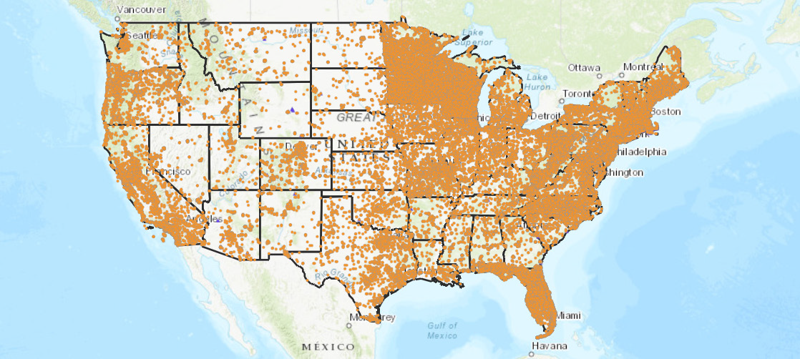

*Figure 4. The US abandoned sites map* [*[53]*](https://paperpile.com/c/7t4MlO/KfQK)

To meet the rising demand for metals, it will be necessary for the mining of raw metals, production of finished metals, and recycling to coexist [[54,55]](https://paperpile.com/c/7t4MlO/Xe2Y+SNeI). The effects of the carbon added tax (CAT) on particular metals and their recycled counterparts are depicted in Figure 5 [[56]](https://paperpile.com/c/7t4MlO/FluM). Many studies on material flow analysis are centered on the copper and steel recycling industries [[54,57,58]](https://paperpile.com/c/7t4MlO/Xe2Y+CreB+hr55). However, the mining and production of raw metals are affected economically more than twice as much by CAT as recycled metal is. Low-grade scrap metal losses are a major problem for recycled metals, and changing the municipal waste management system globally would be necessary to address this problem, and a CAT tax may not necessarily bring in enough money to support that change. The current supply of metals and minerals, even with a theoretical 100% recycling rate, would not be enough to satisfy present or future demand. By 2050, the amount of above-ground stocks needed per person, using copper as an example, is expected to increase by an estimated 2-3.5 times. Material flow analyses show that, due to the fundamental lack of above-ground stocks, current recycling rates can only meet a very small portion of this demand. Thus, supply-demand balances will drive the prices higher to meet the demand for these materials, making the abandoned ores potentially a lucrative venue for mining companies.

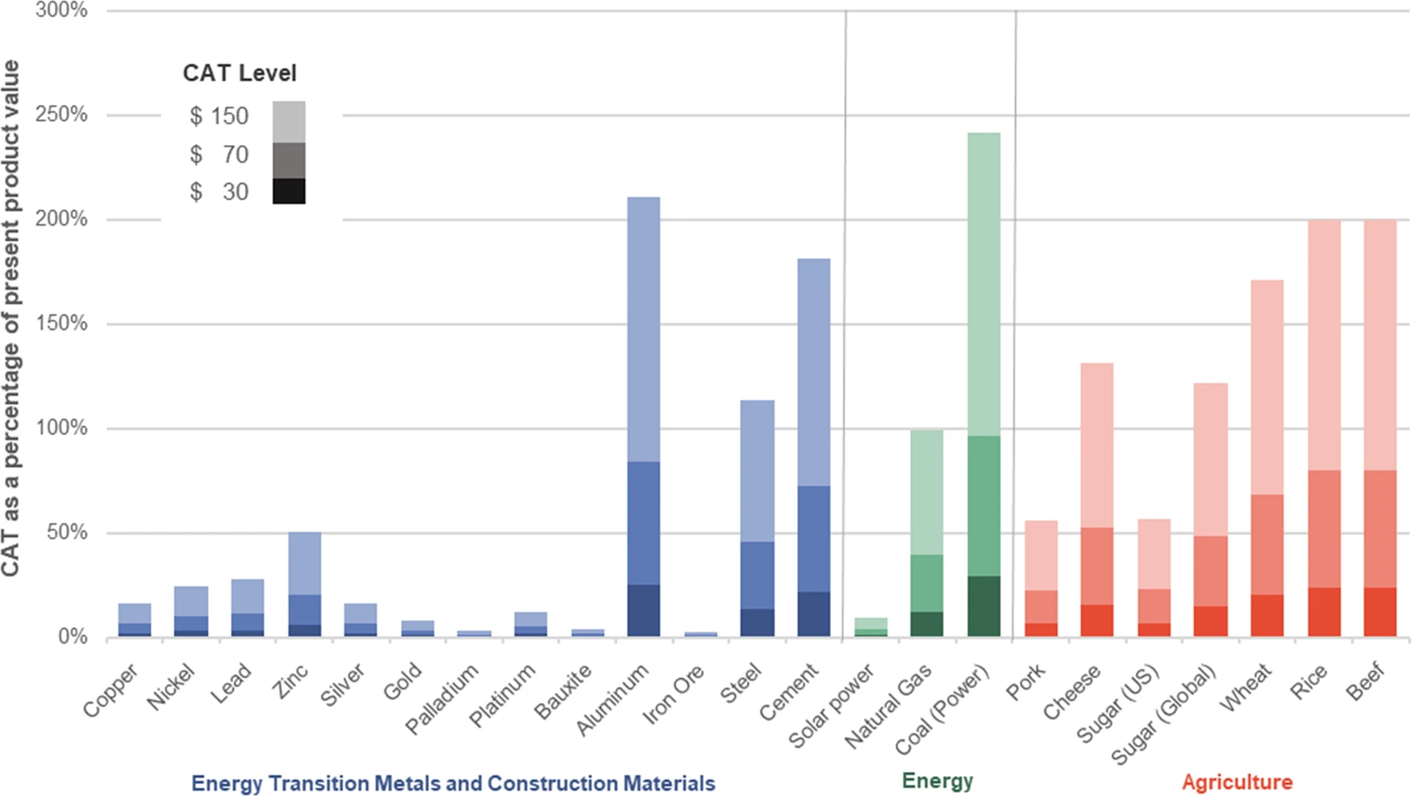

*Figure 5. Three levels of carbon taxation are modeled as a percentage of present product value for selected commodities* [*[56]*](https://paperpile.com/c/7t4MlO/FluM)

According to the McKinsey report, we will see a lack of materials, price increases, and the need for technological innovation and metal substitution because the supply cannot respond quickly enough[[51]](https://paperpile.com/c/7t4MlO/3lIa). Even though the demand for certain metals' raw materials will increase exponentially, the lead times for large-scale new greenfield assets can take up to 7 years and will necessitate a sizable capital investment before actual demand and price incentives are seen. At the same time, with increasingly complex and lower-quality deposits needed, miners will require significant monetary incentives (for example, consistent copper prices of more than $8,000 to $10,000 per metric ton and nickel prices of more than $18,000 per metric ton) before large capital decisions are made. The industry won't be able to handle rapid exponential growth without slack in the system (like strategic stockpiles and overcapacity). A combination of technological development on the supply side and widespread substitution and technological development on the demand side will occur, as was observed, for instance, with the past reduction of cobalt intensity in batteries.

## 

## 

## 3.2. FEASIBILITY STUDY

The expected costs for the cleanup of abandoned mines are expected to be over $54 billion, and taking into account the abovementioned economic value, cleanup and recycling can be coupled with actions to reduce the amount of valuable materials lost and incentivize the mining companies to share the responsibility for cleanup activities and offset the costs of the cleanup for taxpayers, provide job opportunities, and implement the circular economy strategy in action [[52]](https://paperpile.com/c/7t4MlO/75gZ).

Due to the large amount of waste rock generated, coal mines present a viable option for remining and restoration initiatives. The University of West Virginia, in partnership with the WV Department of Environmental Protection, is exploring the extraction of rare earth materials from coal mining waste. This initiative will be able to help with water cleanup and, as a side product, provide materials that are critical for green energy supply and alleviate the negative impact of the initial mining activities [[59]](https://paperpile.com/c/7t4MlO/DrCu). Using this method, acid mine drainage from the northern and central Appalachian coal basins will be collected, treated to meet clean water standards, and the rare earth elements, aluminum, as well as the vital minerals cobalt and manganese, will be extracted (Fig 6 and 7) [[60]](https://paperpile.com/c/7t4MlO/Opzg). The carbon footprint is about one-half as much as a conventional mining and milling operation, according to a principal investigator [[61]](https://paperpile.com/c/7t4MlO/qmPI).

Companies that specialize in the reprocessing of mineral waste have stepped forward with their technical know-how, such as Magnetation in the USA, which uses a magnetic separation technology; BioteQ in Canada, which combines sulfide precipitation and ion-exchange technologies [[62]](https://paperpile.com/c/7t4MlO/Z0gn); and Ecologix in the USA, which uses physicochemical processes involving flocculation and sedimentation [[63]](https://paperpile.com/c/7t4MlO/PS6Z),[[64]](https://paperpile.com/c/7t4MlO/Drpd).

At this stage, more research in this direction needs support to provide a basis for an industrial scale development as well as the opportunities to extract other elements.

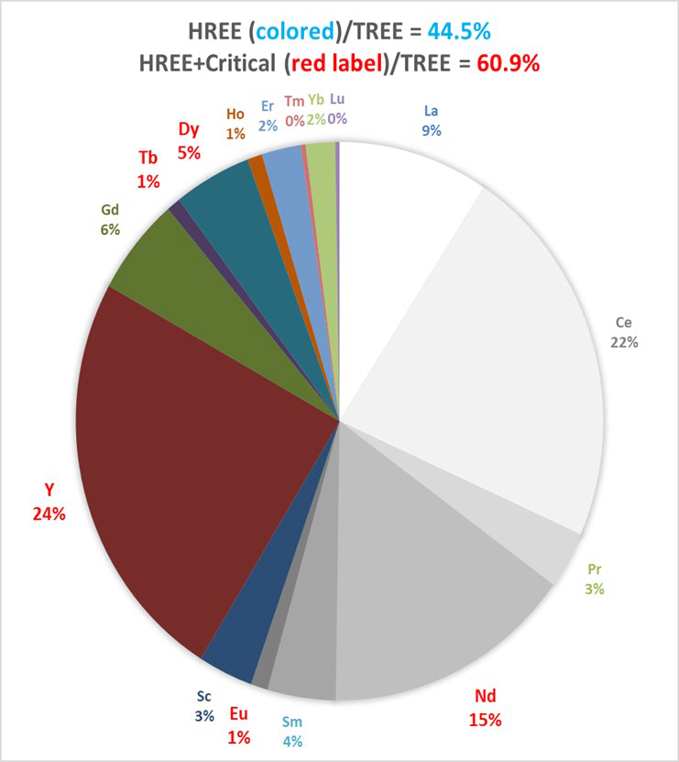

*Figure 6. Acid Mine Drainage contains a high proportion of the valuable critical and heavy rare earth elements (HREE). Together, they comprise about 60% of the total rare earth in Appalachian acid mine drainage*

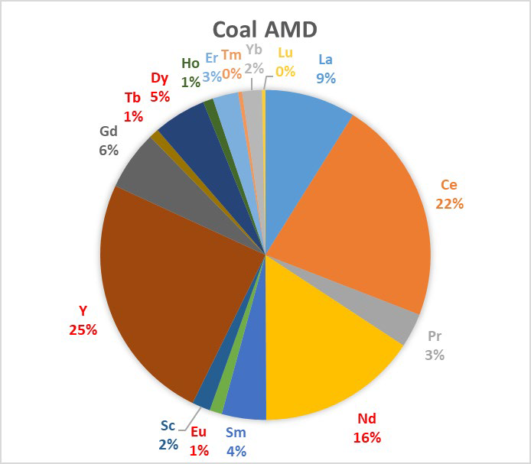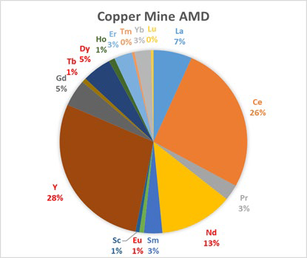

*Figure 7. Distribution of REE in coal and copper mine acid mine drainage. The coal results represent 140 samples from northern and central Appalachian mines. The copper AMD represents two samples from the Berkeley Pit, Butte MT. Red labels represent critical REEs* [*[61]*](https://paperpile.com/c/7t4MlO/qmPI)

# 

## 

## 3.3. AN ENVIRONMENTAL JUSTICE (EJ) ASPECT

Mining has been a controversial aspect of economic development. Despite the emerging need for supply for social good, mining has left a legacy of mining waste abandoned on 500 000 sites across the nation, and some of them are located on Native American lands or, as in the case of abandoned coal mines in Central Appalachia, marginalized communities who bear the negative impact of these projects [[65]](https://paperpile.com/c/7t4MlO/8lvp). Finance company MSCI estimates that the majority of U.S. reserves for cobalt, lithium, and nickel are located within 35 miles of Native American reservations, and many groups associate mineral extraction with their historical memory of dispossession and the disruption of traditional lifestyles [[66,67]](https://paperpile.com/c/7t4MlO/N4UE+CgVR).

Large open pits, chemical and mechanical processes, and other highly industrialized aspects of large-scale modern mining with a lack of economic support for the regions can cause EJ conflicts at various points in the extraction process. These occurrences generate an unequal distribution of negative impacts on the environment and public health, while the other part of the population may have benefited from the produced technologies without facing the negative effects of their production. This is an example of environmental injustice, and the transition to clean energy should not be the cause of this.

Outside of the US, as it imports some of the raw materials from other countries, mining has a negative impact on the population in emerging countries in South America and Africa, Asia, polluting local waters or depleting natural water reserves and increasing concerns over neo-colonialism [[68]](https://paperpile.com/c/7t4MlO/p0RC),[[69]](https://paperpile.com/c/7t4MlO/f8Mh). In the 1990s, a growing share of mineral exploration and investment dollars went toward tropical regions around the world, including ecologically delicate or highly valuable conservation areas [[69]](https://paperpile.com/c/7t4MlO/f8Mh).

Communities may once again experience environmental issues related to mining as the race for renewable energy materials intensifies and lower quality deposits (i.e., those with toxic minerals present) are exploited, causing more water use and waste rock to meet demand, adding to social and environmental pressures [[70]](https://paperpile.com/c/7t4MlO/uSyP). As an inherently invasive process, mining's eco-efficiency and technological approaches are limited and adverse impacts cannot be illuminated completely, and as the quality of deposits is decreasing, that entails the processing of larger amounts of ores. Having previously had negative experiences with mining projects, the local communities may start the conflict before the start of the extraction to protect land, water, or/and bioresources. Especially when, despite frequent claims that mines infringe on rights to fish, hunt, and gather plants guaranteed by treaties, federal mining law gives private companies enormous power to stake claims and dig on public lands. That affects the livelihood of the area and the opportunities for agriculture. Additionally, tribal members have made unsuccessful attempts to prove that mines would make it illegal for them to pray and practice their religions on holy public lands [[71]](https://paperpile.com/c/7t4MlO/DFIt). Thus, pristine mines will exacerbate social inequality and environmental injustice instead of mitigating existing problems related to abandoned sites that are inhabitable.

The approach discussed above would allow for extraction, quality control, and, to a certain extent (since it will require special equipment and, depending on the nature of the waste, special treatment plans), cleanup activities; provide jobs to the local communities and, thus, economic development; and at the same time, extract valuable resources from the mining waste that has not been used for any purpose and has been polluting the rivers and groundwater. In this case, the local communities will have a chance to be involved in all steps, protecting their interests and protecting other pristine lands that otherwise would be disturbed.

# CONCLUSION

As the transition to renewable energy sources gets massive support, energy generated from renewable energy sources will grow by 2050, leading to rapid demand for technology-specific critical materials. At the same time, energy security concerns require considering local raw materials extraction to avoid dependence on imports. This may lead to intensifying mining activities and conflicts with local communities and tribes where ores are located. From an economic, feasibility, and environmental justice perspective, the option of remaining abandoned mine waste to extract critical elements for technologies and REEs was explored. This method may help in the reduction of cleanup costs as well as prevent the mining of pristine lands and avoid the environmental justice issue. On the other hand, this method may provide an avenue for local communities to control the cleanup efforts, and provide jobs and materials to the manufacturers, all at a market price.

# ACKNOWLEDGEMENT

This research was supported by the Gateway for Accelerated Innovation in Nuclear.

# 

# 

# REFERENCES

1. [Zhang T, Shi X, Zhang D, Xiao J. Socio-economic development and electricity access in developing economies: A long-run model averaging approach. Energy Policy. 2019;132: 223–231. doi:](http://paperpile.com/b/7t4MlO/ltxE)[10.1016/j.enpol.2019.05.031](http://dx.doi.org/10.1016/j.enpol.2019.05.031)

2. [Apergis N, Payne JE. Renewable and non-renewable energy consumption-growth nexus: Evidence from a panel error correction model. Energy Econ. 2012;34: 733–738. doi:](http://paperpile.com/b/7t4MlO/3MUiv)[10.1016/j.eneco.2011.04.007](http://dx.doi.org/10.1016/j.eneco.2011.04.007)

3. [Iea I. World energy balances: Overview. IEA Paris; 2020.](http://paperpile.com/b/7t4MlO/47hcW)

4. [Renewable electricity growth is accelerating faster than ever worldwide, supporting the emergence of the new global energy economy. In: IEA [Internet]. [cited 31 May 2022]. Available:](http://paperpile.com/b/7t4MlO/gzztf) <https://www.iea.org/news/renewable-electricity-growth-is-accelerating-faster-than-ever-worldwide-supporting-the-emergence-of-the-new-global-energy-economy>

5. [President Biden’s Bipartisan Infrastructure Law. In: The White House [Internet]. 6 Nov 2021 [cited 9 Aug 2022]. Available:](http://paperpile.com/b/7t4MlO/XucX) <https://www.whitehouse.gov/bipartisan-infrastructure-law/>

6. [Bauer C, Treyer K, Heck T, Hirschberg S. Greenhouse Gas Emissions from Energy Systems, Comparison, and Overview☆. Reference Module in Earth Systems and Environmental Sciences. 2015. doi:](http://paperpile.com/b/7t4MlO/RUomg)[10.1016/b978-0-12-409548-9.09276-9](http://dx.doi.org/10.1016/b978-0-12-409548-9.09276-9)

7. [International Atomic Energy Agency. Comparison of Energy Sources in Terms of Their Full-energy-chain Emission Factors of Greenhouse Gases: Proceedings of an IAEA Advisory Group Meeting. IAEA; 1996. Available:](http://paperpile.com/b/7t4MlO/o4QIr) <https://play.google.com/store/books/details?id=YLy_uQEACAAJ>

8. [Dunn JB, James C, Gaines L, Gallagher K, Dai Q, Kelly JC. Material and energy flows in the production of cathode and anode materials for lithium ion batteries. Argonne National Lab. (ANL), Argonne, IL (United States); 2015 Sep. Report No.: ANL/ESD-14/10 Rev. doi:](http://paperpile.com/b/7t4MlO/NujaX)[10.2172/1224963](http://dx.doi.org/10.2172/1224963)

9. [Giurco D, Dominish E, Florin N, Watari T, McLellan B. Requirements for Minerals and Metals for 100% Renewable Scenarios. In: Teske S, editor. Achieving the Paris Climate Agreement Goals: Global and Regional 100% Renewable Energy Scenarios with Non-energy GHG Pathways for +15°C and +2°C. Cham: Springer International Publishing; 2019. pp. 437–457. doi:](http://paperpile.com/b/7t4MlO/7UQMm)[10.1007/978-3-030-05843-2_11](http://dx.doi.org/10.1007/978-3-030-05843-2_11)

10. [Sonter LJ, Dade MC, Watson JEM, Valenta RK. Renewable energy production will exacerbate mining threats to biodiversity. Nat Commun. 2020;11: 4174. doi:](http://paperpile.com/b/7t4MlO/qobBO)[10.1038/s41467-020-17928-5](http://dx.doi.org/10.1038/s41467-020-17928-5)

11. [Navarro MC, Pérez-Sirvent C, Martínez-Sánchez MJ, Vidal J, Tovar PJ, Bech J. Abandoned mine sites as a source of contamination by heavy metals: A case study in a semi-arid zone. J Geochem Explor. 2008;96: 183–193. doi:](http://paperpile.com/b/7t4MlO/AFgDY)[10.1016/j.gexplo.2007.04.011](http://dx.doi.org/10.1016/j.gexplo.2007.04.011)

12. [Florin N, Dominish E. Sustainability evaluation of energy storage technologies. 2017. Available:](http://paperpile.com/b/7t4MlO/eNHVC) <https://opus.cloud.lib.uts.edu.au/bitstream/10453/121977/1/ACOLA%20WP%203%20SustainabilityEvaluationofEnergyStorageTechnologies.pdf>

13. [Sim M-S, Ju H-T, Kim K-S, Kim J-S. Case studies of geophysical mapping of hazard and contaminated zones in abandoned mine lands. J Eng Geol. 2014;24: 525–534. doi:](http://paperpile.com/b/7t4MlO/6cij)[10.9720/kseg.2014.4.525](http://dx.doi.org/10.9720/kseg.2014.4.525)

14. [Rare earth elements project receives federal funding. [cited 1 Aug 2022]. Available:](http://paperpile.com/b/7t4MlO/dXKG) <https://www.uwyo.edu/uw/news/2020/06/rare-earth-elements-project-receives-federal-funding.html>

15. [International mine water association. Mine Water Environ. 2002;21: 152–152. doi:](http://paperpile.com/b/7t4MlO/90D4)[10.1007/s102300200036](http://dx.doi.org/10.1007/s102300200036)

16. [Clean energy demand for critical minerals set to soar as the world pursues net zero goals. In: IEA [Internet]. [cited 9 Aug 2022]. Available:](http://paperpile.com/b/7t4MlO/VbBR) <https://www.iea.org/news/clean-energy-demand-for-critical-minerals-set-to-soar-as-the-world-pursues-net-zero-goals>

17. [UNITED NATIONS ECONOMIC COMMISSION FOR EUROPE. Carbon Neutrality in the UNECE Region: Integrated Life-cycle Assessment of Electricity Sources. UNECE; 2022 Mar.](http://paperpile.com/b/7t4MlO/rwCq)

18. [Lèbre É, Stringer M, Svobodova K, Owen JR, Kemp D, Côte C, et al. The social and environmental complexities of extracting energy transition metals. Nat Commun. 2020;11: 4823. doi:](http://paperpile.com/b/7t4MlO/dTNE)[10.1038/s41467-020-18661-9](http://dx.doi.org/10.1038/s41467-020-18661-9)

19. [Ballinger B, Stringer M, Schmeda-Lopez DR, Kefford B, Parkinson B, Greig C, et al. The vulnerability of electric vehicle deployment to critical mineral supply. Appl Energy. 2019;255: 113844. doi:](http://paperpile.com/b/7t4MlO/NHi5)[10.1016/j.apenergy.2019.113844](http://dx.doi.org/10.1016/j.apenergy.2019.113844)

20. [DoE US. Quadrennial technology review 2015. US Department of Energy, Washington, DC. 2015.](http://paperpile.com/b/7t4MlO/tvzei)

21. [Schwarz H-G. Aluminum Production and Energy. Encyclopedia of Energy. 2004. pp. 81–95. doi:](http://paperpile.com/b/7t4MlO/DQwVv)[10.1016/b0-12-176480-x/00372-7](http://dx.doi.org/10.1016/b0-12-176480-x/00372-7)

22. [Agency IRE. Future of solar photovoltaic: deployment, investment, technology, grid integration and socio-economic aspects. A Global Energy Transformation. 2019.](http://paperpile.com/b/7t4MlO/vxVFG)

23. [International Aluminium Institute publishes global recycling data. In: Aluminium International Today [Internet]. [cited 22 May 2022]. Available:](http://paperpile.com/b/7t4MlO/X9nMk) <https://aluminiumtoday.com/news/international-aluminium-institute-publishes-global-recycling-data>

24. [Elchalakani M, Aly T, Abu-Aisheh E. Sustainable concrete with high volume GGBFS to build Masdar City in the UAE. Case Studies in Construction Materials. 2014;1: 10–24. doi:](http://paperpile.com/b/7t4MlO/OAhEF)[10.1016/j.cscm.2013.11.001](http://dx.doi.org/10.1016/j.cscm.2013.11.001)

25. [Soares A. Copper scrap boasts decarbonization benefits amid challenging market dynamics. 3 Mar 2022 [cited 22 May 2022]. Available:](http://paperpile.com/b/7t4MlO/MHJcC) <https://www.spglobal.com/marketintelligence/en/news-insights/research/copper-scrap-boasts-decarbonization-benefits-amid-challenging-market-dynamics>

26. [Muwanguzi AJB, Karasev AV, Byaruhanga JK, Jönsson PG. Characterization of chemical composition and microstructure of natural iron ore from Muko deposits. International Scholarly Research Notices. 2012;2012. Available:](http://paperpile.com/b/7t4MlO/epWdK) <https://downloads.hindawi.com/archive/2012/174803.pdf>

27. [U. s. Government Printing Office. Minerals Yearbook: Metals and Minerals 2009. U.S. Government Printing Office; 2011. Available:](http://paperpile.com/b/7t4MlO/xqM7J) <https://play.google.com/store/books/details?id=IFInpwAACAAJ>

28. [Grandell L, Höök M. Assessing Rare Metal Availability Challenges for Solar Energy Technologies. Sustain Sci Pract Policy. 2015;7: 11818–11837. doi:](http://paperpile.com/b/7t4MlO/y7NYz)[10.3390/su70911818](http://dx.doi.org/10.3390/su70911818)

29. [Matasci S. Solar panel size and weight: How big are solar panels? In: EnergySage Blog [Internet]. EnergySage; 1 Dec 2021 [cited 22 May 2022]. Available:](http://paperpile.com/b/7t4MlO/Z3Ehv) <https://news.energysage.com/average-solar-panel-size-weight/>

30. [Ponikvar AL, Goodwin FE. lead processing. Encyclopedia Britannica. 2013. Available:](http://paperpile.com/b/7t4MlO/3XudE) <https://www.britannica.com/technology/lead-processing>

31. [Fraunhofer ISE. Recent facts about photovoltaics in Germany. Fraunhofer Institute for Solar Energy Systems ISE, Freiburg. 2017.](http://paperpile.com/b/7t4MlO/dneOc)

32. [Mason JE, Fthenakis VM, Hansen T, Kim HC. Energy payback and life-cycle CO2 emissions of the BOS in an optimized 3·5 MW PV installation. Prog Photovoltaics Res Appl. 2006;14: 179–190. doi:](http://paperpile.com/b/7t4MlO/hQCmV)[10.1002/pip.652](http://dx.doi.org/10.1002/pip.652)

33. [Moore, Post, Mysak. Photovoltaic power plant experience at Tucson electric power. Atlantis Stud Math Eng Sci. Available:](http://paperpile.com/b/7t4MlO/rskIW) <https://asmedigitalcollection.asme.org/IMECE/proceedings-abstract/IMECE2005/387/310293>

34. [Huber ST, Steininger KW. Critical sustainability issues in the production of wind and solar electricity generation as well as storage facilities and possible solutions. J Clean Prod. 2022;339: 130720. doi:](http://paperpile.com/b/7t4MlO/N7SUt)[10.1016/j.jclepro.2022.130720](http://dx.doi.org/10.1016/j.jclepro.2022.130720)

35. [Barry BTK. tin processing. Encyclopedia Britannica. 2017. Available:](http://paperpile.com/b/7t4MlO/0qnC0) <https://www.britannica.com/technology/tin-processing>

36. [Alsaleh A, Sattler M. Comprehensive life cycle assessment of large wind turbines in the US. Clean Technol Environ Policy. 2019;21: 887–903. doi:](http://paperpile.com/b/7t4MlO/Rc6LK)[10.1007/s10098-019-01678-0](http://dx.doi.org/10.1007/s10098-019-01678-0)

37. [Richards AW. zinc processing. Encyclopedia Britannica. 2019. Available:](http://paperpile.com/b/7t4MlO/Kt7W8) <https://www.britannica.com/technology/zinc-processing>

38. [Wilburn DR. Wind energy in the United States and materials required for the land-based wind turbine industry from 2010 through 2030. Scientific Investigations Report. US Geological Survey; 2011. pp. i–19. doi:](http://paperpile.com/b/7t4MlO/yQeDV)[10.3133/sir20115036](http://dx.doi.org/10.3133/sir20115036)

39. [Gschneidner KA, Jr., Pecharsky VK. rare-earth element. Encyclopedia Britannica. 2019. Available:](http://paperpile.com/b/7t4MlO/rzBD9) <https://www.britannica.com/science/rare-earth-element>

40. [Dias PA, Bobba S, Carrara S, Plazzotta B. THE ROLE OF RARE EARTH ELEMENTS IN WIND ENERGY AND ELECTRIC MOBILITY An analysis of future supply/demand balances. unknown; 2021 Jan. doi:](http://paperpile.com/b/7t4MlO/mMi8n)[10.2760/303258](http://dx.doi.org/10.2760/303258)

41. [International Energy Agency. The Role of Critical Minerals in Clean Energy Transitions. OECD Publishing; 2021. Available:](http://paperpile.com/b/7t4MlO/HELO4) <https://play.google.com/store/books/details?id=YU4RzwEACAAJ>

42. [Samuel Carrara, Patricia Alves Dias, Beatrice Plazzotta, Claudiu Pavel. Raw materials demand for wind and solar PV technologies in the transition towards a decarbonised energy system. Publication Office of the European Union, Luxembourg; 2020.](http://paperpile.com/b/7t4MlO/vbpJd)

43. [Moss, Tzimas, Kara, Willis, Arendorf. Assessing rare metals as supply-chain bottlenecks in low-carbon energy technologies. European Commission.](http://paperpile.com/b/7t4MlO/j2sk8)

44. [Downing JH, Bacon FE. chromium processing. Encyclopedia Britannica. 2013. Available:](http://paperpile.com/b/7t4MlO/3QKBS) <https://www.britannica.com/technology/chromium-processing>

45. [Downing JH. manganese processing. Encyclopedia Britannica. 2013. Available:](http://paperpile.com/b/7t4MlO/FcAUC) <https://www.britannica.com/technology/manganese-processing>

46. [Sutulov A, Wang CT. molybdenum processing. Encyclopedia Britannica. 2018. Available:](http://paperpile.com/b/7t4MlO/pxZZ3) <https://www.britannica.com/technology/molybdenum-processing>

47. [Verma S, Paul AR, Haque N. Assessment of Materials and Rare Earth Metals Demand for Sustainable Wind Energy Growth in India. Minerals. 2022;12: 647. doi:](http://paperpile.com/b/7t4MlO/f68MB)[10.3390/min12050647](http://dx.doi.org/10.3390/min12050647)

48. [Wise EM, Taylor JC. nickel processing. Encyclopedia Britannica. 2013. Available:](http://paperpile.com/b/7t4MlO/qj9w0) <https://www.britannica.com/technology/nickel-processing>

49. [Eckermann D. Materials use in a Clean Energy future. In: Bright New World [Internet]. 26 Jun 2021 [cited 3 Aug 2022]. Available:](http://paperpile.com/b/7t4MlO/as8OT) <https://www.brightnewworld.org/media/2021/1/27/materials-use-project>

50. [Pacca S, Horvath A. Greenhouse gas emissions from building and operating electric power plants in the Upper Colorado River Basin. Environ Sci Technol. 2002;36: 3194–3200. doi:](http://paperpile.com/b/7t4MlO/F1a44)[10.1021/es0155884](http://dx.doi.org/10.1021/es0155884)

51. [The raw-materials challenge: How the metals and mining sector will be at the core of enabling the energy transition. McKinsey & Company; 10 Jan 2022 [cited 10 Aug 2022]. Available:](http://paperpile.com/b/7t4MlO/3lIa) <https://www.mckinsey.com/industries/metals-and-mining/our-insights/the-raw-materials-challenge-how-the-metals-and-mining-sector-will-be-at-the-core-of-enabling-the-energy-transition>

52. [Home. [cited 10 Aug 2022]. Available:](http://paperpile.com/b/7t4MlO/75gZ) <https://naturalresources.house.gov>

53. [U.S. Environmental Protection Agency. Choice . 2001;38: 38Sup–245–38Sup–245. doi:](http://paperpile.com/b/7t4MlO/KfQK)[10.5860/choice.38sup-245](http://dx.doi.org/10.5860/choice.38sup-245)

54. [Fu X, Ueland SM, Olivetti E. Econometric modeling of recycled copper supply. Resour Conserv Recycl. 2017;122: 219–226. doi:](http://paperpile.com/b/7t4MlO/Xe2Y)[10.1016/j.resconrec.2017.02.012](http://dx.doi.org/10.1016/j.resconrec.2017.02.012)

55. [Gerst MD, Graedel TE. In-use stocks of metals: status and implications. Environ Sci Technol. 2008;42: 7038–7045. doi:](http://paperpile.com/b/7t4MlO/SNeI)[10.1021/es800420p](http://dx.doi.org/10.1021/es800420p)

56. [Cox B, Innis S, Kunz NC, Steen J. The mining industry as a net beneficiary of a global tax on carbon emissions. Communications Earth & Environment. 2022;3: 1–8. doi:](http://paperpile.com/b/7t4MlO/FluM)[10.1038/s43247-022-00346-4](http://dx.doi.org/10.1038/s43247-022-00346-4)

57. [Glöser S, Soulier M, Tercero Espinoza LA. Dynamic analysis of global copper flows. Global stocks, postconsumer material flows, recycling indicators, and uncertainty evaluation. Environ Sci Technol. 2013;47: 6564–6572. doi:](http://paperpile.com/b/7t4MlO/CreB)[10.1021/es400069b](http://dx.doi.org/10.1021/es400069b)

58. [Ekman Nilsson A, Macias Aragonés M, Arroyo Torralvo F, Dunon V, Angel H, Komnitsas K, et al. A review of the carbon footprint of cu and Zn production from primary and secondary sources. Minerals (Basel). 2017;7: 168. doi:](http://paperpile.com/b/7t4MlO/hr55)[10.3390/min7090168](http://dx.doi.org/10.3390/min7090168)

59. [Skousen JG, Ziemkiewicz PF, McDonald LM. Acid mine drainage formation, control and treatment: Approaches and strategies. The Extractive Industries and Society. 2019;6: 241–249. doi:](http://paperpile.com/b/7t4MlO/DrCu)[10.1016/j.exis.2018.09.008](http://dx.doi.org/10.1016/j.exis.2018.09.008)

60. [Ziemkiewicz P. WVU awarded $5 million to continue rare earth project, build acid mine drainage treatment facility. [cited 10 Aug 2022]. Available:](http://paperpile.com/b/7t4MlO/Opzg) <https://wvutoday.wvu.edu/stories/2019/10/01/wvu-awarded-5-million-to-continue-rare-earth-project-build-acid-mine-drainage-treatment-facility>

61. [U.S. senate committee on energy and natural resources. [cited 10 Aug 2022]. Available:](http://paperpile.com/b/7t4MlO/qmPI) https://www.energy.senate.gov/services/files/3FE0D2F4-1001-44FF-B0C1-9B535DA41935

62. [Key sectors. In: BQE Water [Internet]. 13 Nov 2014 [cited 10 Aug 2022]. Available:](http://paperpile.com/b/7t4MlO/Z0gn) <https://www.bqewater.com/key-sectors/>

63. [Mining Industry Wastewater Treatment systems ». In: Ecologix Systems [Internet]. 27 Sep 2018 [cited 10 Aug 2022]. Available:](http://paperpile.com/b/7t4MlO/PS6Z) <http://www.ecologixsystems.com/industry-mining/>

64. [Lèbre É, Corder GD, Golev A. Sustainable practices in the management of mining waste: A focus on the mineral resource. Miner Eng. 2017;107: 34–42. doi:](http://paperpile.com/b/7t4MlO/Drpd)[10.1016/j.mineng.2016.12.004](http://dx.doi.org/10.1016/j.mineng.2016.12.004)

65. [Hendryx M. Poverty and Mortality Disparities in Central Appalachia: Mountaintop Mining and Environmental Justice. J Health Dispar Res Pract. 2010;4: 6. Available:](http://paperpile.com/b/7t4MlO/8lvp) <https://digitalscholarship.unlv.edu/jhdrp/vol4/iss3/6/>

66. [Block S. Mining energy-transition metals: National aims, local conflicts. [cited 10 Aug 2022]. Available:](http://paperpile.com/b/7t4MlO/N4UE) <https://www.msci.com/www/blog-posts/mining-energy-transition-metals/02531033947>

67. [Keeling A, Sandlos J. Environmental Justice Goes Underground? Historical Notes from Canada’s Northern Mining Frontier. Environ Justice. 2009;2: 117–125. doi:](http://paperpile.com/b/7t4MlO/CgVR)[10.1089/env.2009.0009](http://dx.doi.org/10.1089/env.2009.0009)

68. [Blair JJA, Balcázar RM, Barandiarán J, Maxwell A. Exhausted: How We Can Stop Lithium Mining from Depleting Water Resources, Draining Wetlands, and Harming Communities in South America. unknown; 2022 Apr. Available:](http://paperpile.com/b/7t4MlO/p0RC) <http://dx.doi.org/>

69. [Bridge G. Mapping the Bonanza: Geographies of Mining Investment in an Era of Neoliberal Reform. Prof Geogr. 2004;56: 406–421. doi:](http://paperpile.com/b/7t4MlO/f8Mh)[10.1111/j.0033-0124.2004.05603009.x](http://dx.doi.org/10.1111/j.0033-0124.2004.05603009.x)

70. [Giurco D. Peak minerals in Australia: a review of changing impacts and benefits. Institute for Sustainable Futures(University of Technology, Sydney; Department of Civil Engineering(Monash University); 2010. Available:](http://paperpile.com/b/7t4MlO/uSyP) <https://play.google.com/store/books/details?id=B80DtwAACAAJ>

71. [Healy J, Baker M. As Miners Chase Clean-Energy Minerals, Tribes Fear a Repeat of the Past. The New York Times. 27 Dec 2021. Available:](http://paperpile.com/b/7t4MlO/DFIt) <https://www.nytimes.com/2021/12/27/us/mining-clean-energy-antimony-tribes.html>[. Accessed 10 Aug 2022.](http://paperpile.com/b/7t4MlO/DFIt)